Project Deliverable 5: Infrastructure and Security
Name
Institution
Due Date

Justify and support the relationship between infrastructure and security as it relates to this data-collection and analysis company.
Data is the most important resource or valued asset for a company that collects and analyses data. It goes without saying that such a company will need a security plan that is very tight that cannot be easily compromised. Company value is determined by the analysis of their Big Data that has greatly grown over the years. Information Technology is undoubtedly very important to companies since it is through it that data is stored, analyzed, managed, and protected in a bid to work for the company business operations (Chen, 2012). The value of data in a company is dependent on the type, for instance a bank values most importantly its customers’ data which is attached an inherent value. Other data such the purchasing habit of customers for an organization have a derived value. This is a simple example to depict the variation that exists between different data but the bottom line remains that all these data is resourcefully important to corresponded companies.
As aforementioned, this data needs to be secured and the level of security is dependent on factors like IT infrastructure at the hands of the company. The IT infrastructure and security of the company are related. Among the key tenets of cybersecurity is confidentiality; the transmission of data through a network containing multiple users is kind of risking the data to unauthorized parties. Infrastructure entails access controls and a company having weak access controls is a huge problem that opens up company servers to unauthorized access. The second tenet of cybersecurity is integrity. The nodes of a network needs to be properly set for security reasons. This is, once again a factor of security that is related to a company’s infrastructure. It is possible for data being transmitted between network nodes to be compromised deliberately or unwillingly. This means that the data that the system will receive is malicious and this can lead to very negative effects to the company. More worse is the case of a data breach. Another tenet of security that establishes the relationship of infrastructure and security is the denial of service. It is evident that the network infrastructure of a company will depend on the consistent functioning of all network links that are connecting the network’s component codes. In case of any network disconnection or may be a slowed process, a system will not be able to make available the processes of data collection and analysis (Chen, 2012). System will also get compromised if the company’s infrastructure develops issues. Network tools such as routers, DNS servers, and modems among many other can be compromised in some situations hence leading to system’s unauthorized access.
Present the rationale for the logical and physical topographical layout of the planned network
The current network before upgrading is direct just like networks that exist for small businesses. The elements that comprise both the logical and physical topographical layout of the planned network include database, mail server, and firewalls just to mention a few. These elements form the basis of data collection in a so specialized company (Biswajeet & Saied, 2010).
In the planned network, the company is said to be moving from first floor up to three floors. For the sake of simplicity, the layout will be set to remain the same as the current is. This is to mean that on each floor the layouts remain the same – physical and logical. It is only at the hub where connection is entirely wired, gathered and tied form one point. A router with high-loading capability is needful for the Wi-Fi needs. The server is then set to be shifted to the third floor in such a way that it will not be accessible to unauthorized party.
Design a logical and physical topographical layout of the current and planned network through the use of graphical tools in Microsoft Word or Visio, or an open source alternative such as Dia. Note: The graphically depicted solution is not included in the required page length.
Physical topographical layout of the current Network
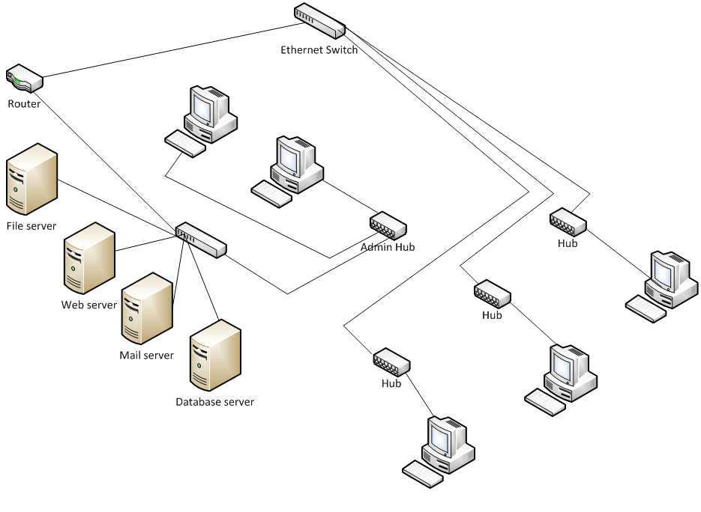
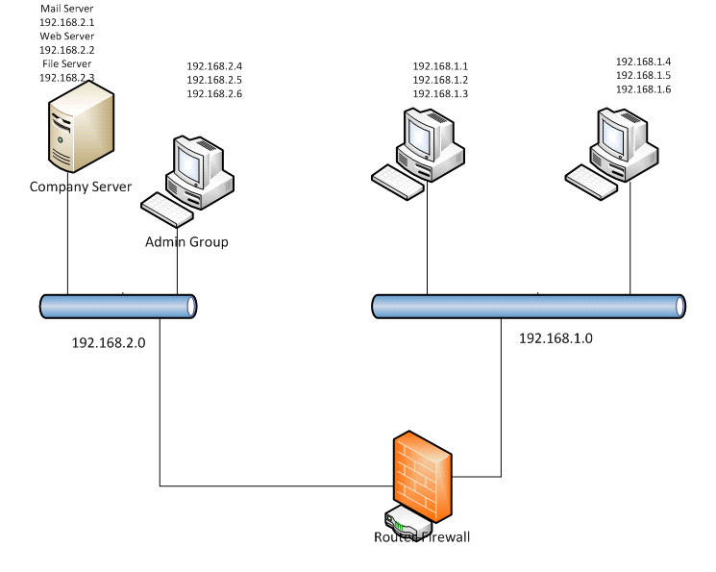
Logical
Physical topographical layout of the planned Network
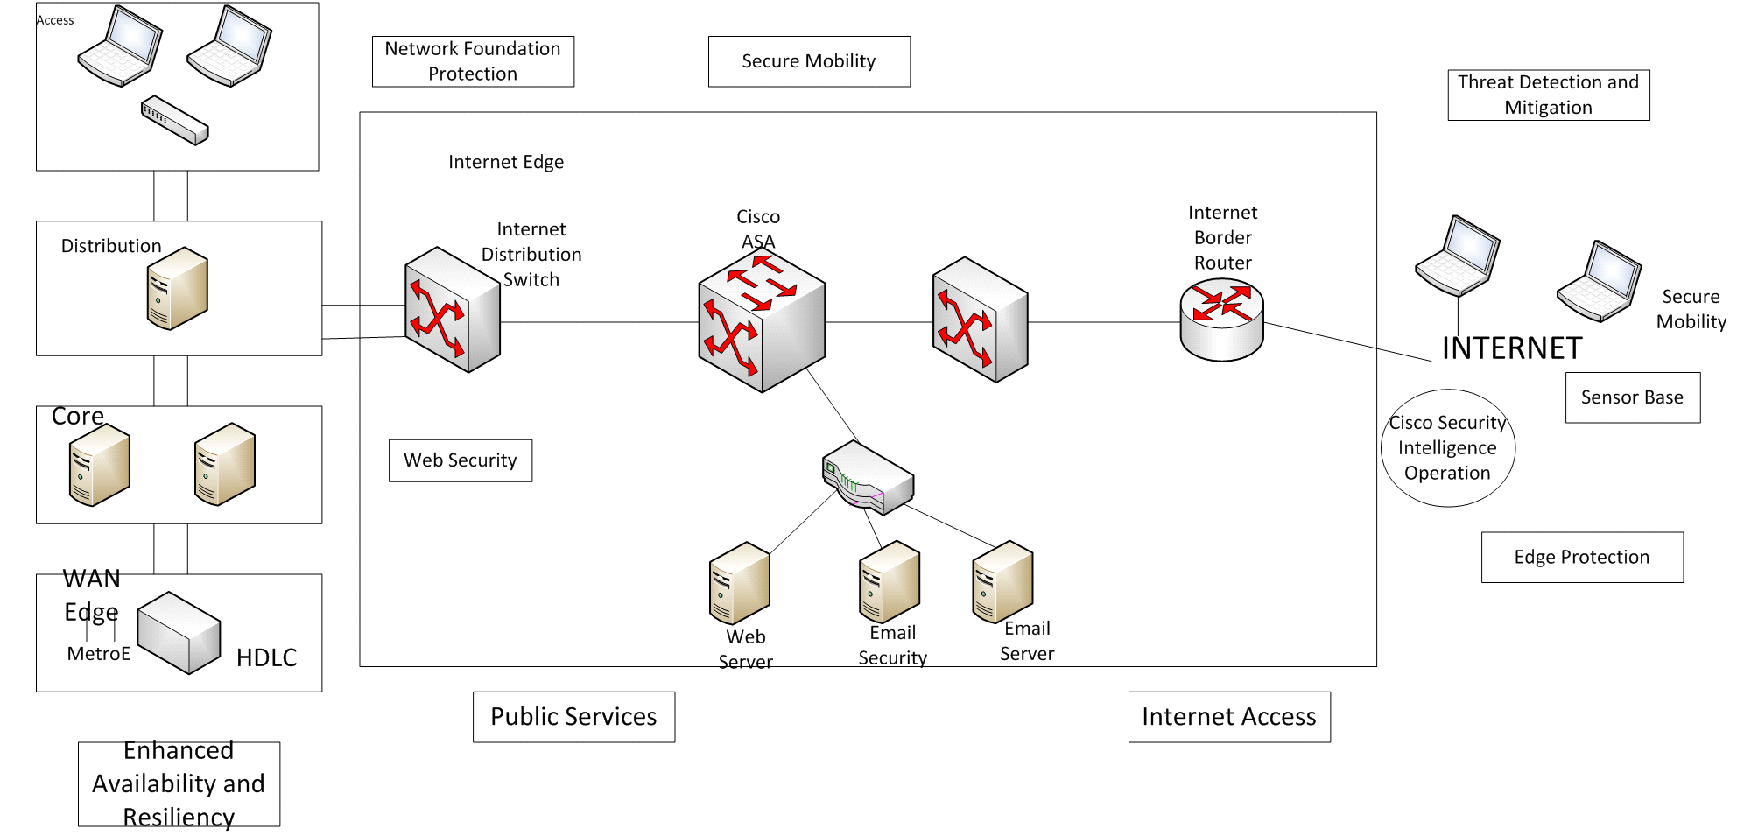

Illustrate the possible placement of servers including access paths to the Internet, intrusion detection systems (IDS), and firewalls.
To enhance availability and resilience, the hardened devices should be configured as illustrated from the diagram. This way, the company achieves optimal services while doing away with system and interface related redundancy.
Also, to ensure maximum availability and resiliency, every device and control as well as management panes need to be protected.
Public Services DMZ placement of devices will ensure that server is protected at the further end and intruders will be kept off by due firewall scrutiny. On the same note, DDoS and deep-packet inspection will be ensured.
Secure mobility which ensures the VN protection of mobile device users is apprehended will perform literally to enforce the independent placement of staffs. This is a service that incorporates web security and virus defense systems.
Edge protection strategy to ensure that routing security, traffic censoring, and firewall is integrated as well as the protection against IP spoofing are key functionalities. This will do away with unauthorized access while blocking non-authentic traffics.
Create and describe a comprehensive security policy for this data-collection and analysis company that will:
As a user, having an access to a company’s system, the user can manipulate the classification of data. A user can change data classification given that there is enough and justifiable reasons of doing the same. To create new data, classification should assume “company only” data up to the point when the one will make modifications. Users are held responsible for change classification they make. Existing company data is classified as:
The business information of the company including memos, budgets, and schedules among others will be regarded as "Company Only". The clients’ data such as bio details, credit information, and contact information will in the same “Company Only" category. Network of the organization and its management is very confidential and, therefore, it will be regarded as “Confidential”. This includes IP configurations, VPN etc. data from the human resource department will be regarded confidential as well since it has details of contracts and salary as well as wage details. Published information such as marketing charts and occasional sales will be regarded as “Shared”. Emails that circulate within the company will be labelled as “Company Only” since it is within the bounds of the company. Emails from outsiders to the company or the other way round will be regarded as “Unclassified”.
Roles & Responsibility classifications
Users should responsibly act to; clearly get the definitions of self-clearance including the rights as well as the existing limitations, ensure that the specific data they will individually work on is classified correctly, make sure that data is well-protected, and lastly, it is vital to ensure that any restrictions in a given data are adhered to.
System owners & administrators are entitled to; establish the security level of all the users, make due equipment installations as expected, and verify the equipment’s that the users will work on.
Divisional managers will have the obligations to; obtain approval upon employee clearance, make clarity on data classification on systems, ensuring that equipment are clearly classified, and implementing the correct policy.
Security Officer’s obligations will be; the approval of classifications, maintaining (management and monitoring) trusted points, maintaining all classifications, and approving the final layout of the company’s network.
Compliance
First, any case of trespass to the system’s devices and due data is bound to be summoned to the disciplinary committee.
Second, a user who has transferred privileges for the sake of someone else having to sufficiently cleared similarly should face the disciplinary committee for due diligence.
Any of the system users who happens to promiscuous access an unauthorized access within the system’s network should follow the disciplinary suit.
Data is bound to be transmitted over the network with an utmost purpose. Any transmission without a clear purpose is an abuse of privilege and the concerned should face disciplinary action.
References
Biswajeet, P., & Saied, P. (2010). Comparison between prediction capabilities of neural network and fuzzy logic techniques for L and slide susceptibility mapping. Disaster Advances, 3(3), 26-34.
Chen, H., Chiang, R. H., & Storey, V. C. (2012). Business intelligence and analytics: From big data to big impact. MIS quarterly, 36(4).
Zhao, L., Sun, W., Shi, Y., & Liu, J. (2018). Optimal placement of cloudlets for access delay minimization in sdn-based internet of things networks. IEEE Internet of Things Journal, 5(2), 1334-1344.

